Software Requirements Specification

for

Delivery of e-Services to State Citizens
Version 0.2
Prepared by
Abhijeet Sharma d1153001
Dilkhush Soni d1153008
G.Narendra Kumar d1153011
Sanjay Kumar Kunwar d1153027
Siddhatrtha Khatri d1153031
Vishnu Yadav d1153036
C-DAC Bangalore
23-05-2012

Table of Contents

Revision History iv
1.Introduction 5
1.1Purpose 5
1.2Document Conventions 5
1.3 Intended Audience and Reading Suggestions 5
1.4 Product Scope 5
1.5 References 6
2. Overall Description 6
2.1 Product Perspective 6
2.2 Product Functions 7
2.3 User Classes and Characteristics 7
2.4 Operating Environment 8
2.5 Design and Implementation Constraints 8
2.6 User Documentation 8
2.7 Assumptions and Dependencies 8
3. External Interface Requirements 9
3.1User Interfaces 9
3.2 Hardware Interfaces 9
3.3 Software Interfaces 9
3.4 Communications Interfaces 9
4. e-Services Portal Features 9
4.1 Citizen Registration 10
4.1.1 Description and Priority 10
4.1.2 Stimulus/Response Sequences 10
4.1.3 Functional Requirements 10
4.2 Citizen Profile Management 10
4.2.1 Description and Priority 10
4.2.2 Stimulus/Response Sequences 10
4.2.3 Functional Requirements 11
4.3 Online Application Submission 11
4.3.1 Description and Priority 11
4.3.3 Functional Requirements 11
4.4 Citizen Account Management 11
4.4.1 Description and Priority 11
4.4.2 Stimulus/Response Sequences 12
4.5 User Activity and Session Management 12
4.5.1 Description and Priority 12
4.5.2 Stimulus/Response Sequences 12
4.6 Report Generation 12
4.6.1 Description and Priority 12
4.6.2 Stimulus/Response Sequences 12
5. Back Office System Features 12
5.1 Officer Profile Management 13
5.1.1 Description and Priority 13
5.1.2 Stimulus/Response Sequences 13
5.1.3 Functional Requirements 13
5.2 Officer Account Management 13
5.2.1 Description and Priority 13
5.2.2 Stimulus/Response Sequences 13
5.3 Officer Activity and Session Management 14
5.3.1 Description and Priority 14
5.3.2 Stimulus/Response Sequences 14
5.4 Report Generation 14
5.4.1 Description and Priority 14
5.4.2 Stimulus/Response Sequences 14
5.5 Application Processing 14
5.5.1 Description and Priority 14
5.5.2 Stimulus/Response Sequences 15
5.5.3 Functional Requirements 15
5.6 Intelligent Routing Of Applications 15
5.6.1 Description and Priority 15
5.6.2 Stimulus/Response Sequences 15
5.7 Dashboard Facility 15
5.7.1 Description and Priority 15
5.7.2 Stimulus/Response Sequences 15
5.7.3 Functional Requirements 16
5.8 Application Status Update 16
5.8.1 Description and Priority 16
5.8.2 Stimulus/Response Sequences 16
5.8.3 Functional Requirements 16
6.Other Nonfunctional Requirements 16
6.1 Performance Requirements 16
6.1.1 Identify business operations : 16
6.1.2 Identify test data : 17
6.1.3 Response Time : 17
6.1.4 Scalability : 17
6.1.5 Capacity : 18
6.2 Safety Requirements 18
6.3 Security Requirements 19
6.4 Software Quality Attributes 19
6.4.1 Reliability 19
6.4.2 Usability 19
6.4.3 Availability 19
6.4.4 Maintainability 19
Application will be visible to only permitted officers according to role based hierarchical system. 20
Password policy 20
Session policy 20
Appendix A: Glossary 21
Acronyms and abbreviations: 21

Revision History
Name | Date | Reason For Changes | Version | Reviewed By
Delivery of e-Services to State Citizens | 22/05/12 | It is the first version. | 0.1 | Mr. Ravi Sinha
Delivery of e-Services to State Citizens | 23/05/12 | Modified some sections of the document. | 0.2

1.Introduction

1.1Purpose
This document is the SRS of “Delivery of e-Services to State Citizens “ project. Purpose of this document is to introduce about the project and to lay down the requirements of various functionalities to be implemented.
The aim of this project is to develop a system to deliver various e-governance services to the citizens of the state. The end users of this system will be the citizens of the state, CSC operators, State-government officers and administrator(s). This project will require to create two subsystems viz., e-Services portal and the Back-Office system.
The e-Services portal will be beneficial in terms of efficiency,availability and reliability for both the citizens of the state and employees of various state-government departments.

1.2Document Conventions
The heading and sub heading are of font size 18 and 14 respectively in Arial font style. All other text is of size 11 and in Arial font style. This SRS is as per IEEE 830 standards.

1.3 Intended Audience and Reading Suggestions
This project is intended for developers, designers, project managers, citizens,state Government officers, administrator and testers.
- The user should go through the introduction to start reading this document.
- Developer should first go through the introduction and then external interface requirements.
- Designer should keep in mind of all the user classes specified under the specification. For testing the tester should go through the whole description and system features.
- For project manager all the parts are must as from the introduction then overall description,external interface requirement,system features and other non functional requirements.

1.4 Product Scope
There will be two systems to be implemented viz. e-Services portal and Back office system. Major features to be implemented in e-services portal are:
- citizen registration
- citizen profile management
- online application submission
- citizen account management
- user activity and session management
- report generation
Major features to be implemented in the Back-Office system are:
- officer profile management
- officer account management
- officer activity and session management
- report generation
- application processing
- intelligent routing of applications
- dashboard facilty
- application status update

1.5 References
- http://en.wikipedia.org/wiki/Software_requirements_specification (IEEE 830 )
- http://ssdg.cdacmumbai.in/faq.shtml

2. Overall Description

2.1 Product Perspective
One of the objectives of e-Services portal is to make the service available round the clock. E-Services portal provides various services of government departments online. Citizen uses the services offered by the e-Services portal and submits application online. Frequent visits to the Government offices can be avoided using the e-Services portal. Another objective is to provide transparent, efficient and secure delivery of services. The citizen can track the status of their requested service and get all the information required to avail the service. The portal also allows the citizen to perform the transactions in a secure manner.
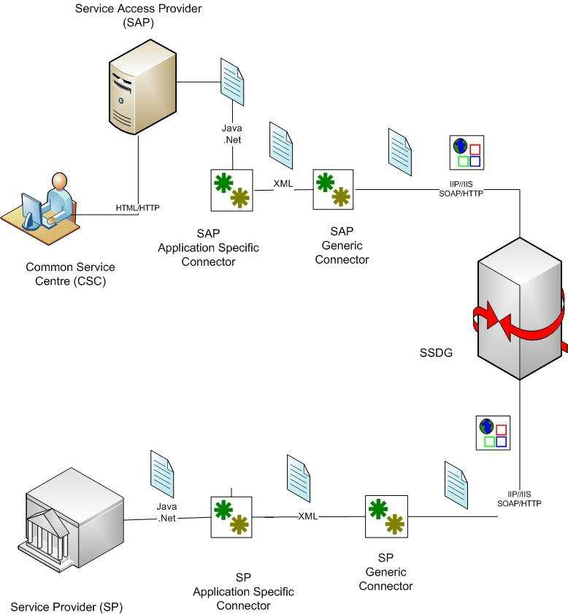

Fig: 2.1 Connectors in Simple Gateway Structure Source:Java Connector Manualv0.2 for SSDG

2.2 Product Functions
- It will provide functions like
1. Issuing Citizen ID.
2. TBD.

2.3 User Classes and Characteristics
This product is to be used by the citizen, administrator and employee of the state-Government .
- Officers : Officers will have the privileges to process the application submitted by a citizen and forward it to the concerned administrator of the department.

- Citizens: Citizen after getting registered with the e-Services System will have the privileges for using various e-Services.

- CSC operators: CSC Operators will have the privilege to create Citizens account on the request. CSC Operators should have basic knowledge of computer operations.

- Administrator: Administrator will have privilege to do account management related operations. Moreover the administrator will also have the privileges to add or modify Officers and CSC Operators account. Administrator must be proficient in computer operations.

2.4 Operating Environment
Software:-
Browser Internet Explorer 8.0+, Mozilla Firefox 3.0 +.
Operating System Windows Xp/Vista/ Windows 7, Ubuntu 7.04 +.

2.5 Design and Implementation Constraints
The system will require to use the SSDG middle ware which are going to impose some design constraints that are as follows:
- Only a maximum of 2MB packet size is allowed.
- All communication through SSDG will be done using XML messages only.

2.6 User Documentation
Other deliverables with the product are :-
- User manual.
- Read Me.
- Installation Manual.
- Administrator Manual.

2.7 Assumptions and Dependencies
- Administrator will have all the records related to CSC Operators and Officers.
- The System will require broad band network connectivity with at least 256KBPS speed.
- The System's functionality depends upon SSDG middle ware.

3. External Interface Requirements

3.1User Interfaces
User will interact with the system through web based interface. This product have following Module Interfaces:
- Administrator
- CSC Operator
- Citizen
- Officer

3.2 Hardware Interfaces
No hardware interfaces has been identified as such for e-Services portal and back-office system.

3.3 Software Interfaces
- Communication Language : XML (as SSDG middleware interact through XML only)

3.4 Communications Interfaces
- It's required to use the SSDG middleware for the purpose of interaction between the e-Services portal and the back office system. To connect these two systems with SSDG middleware IIP-IIS protocol is required.
- Capability of transferring both synchronous and asynchronous messages between e-services portal and the back office system will be provided.
- All communication will be provided with SOAP protocol.

4. e-Services Portal Features
The proposed e-Services portal will have features like citizen registration, citizen profile management, citizen account management, user activity and session management, report generation, online application submission.

4.1 Citizen Registration

4.1.1 Description and Priority
The citizen register with the system to avail the services offered by the Government.After registration, citizen is given a citizen id which is unique acrossthe country. Citizen is also given a login id and password. Citizen can print theregistration card after successful registration.
Priority: High

4.1.2 Stimulus/Response Sequences
Stimulus: Citizen provides basic information about himself/herself and submits registration form.
Response: After registration a citizen is given a citizen id which is unique across the country. A citizen is also given a login id with a password. Citizen can print the registration card.

4.1.3 Functional Requirements
CR-01: Citizen who wishes to avail the services offered by the Government fills the registration form.
CR-02: Input field validation will be taken care by the system.
CR-03: Registration form includes attachments to be uploaded eg. photograph.

4.2 Citizen Profile Management

4.2.1 Description and Priority
Citizen can view and update his/her profile after registering with the system.
Priority: Low.

4.2.2 Stimulus/Response Sequences
Stimulus: Citizen logs in the system selects profile section.
Response: System displays update profile and change password options.
Stimulus: Citizen selects the update profile option.
Response: Citizen profile page is displayed.
Stimulus: Citizen edits the profile information.
Response: Citizen profile gets updated.
Stimulus: Citizen selects the change password option.
Response: System displays the change password form.
Stimulus: Citizen enters the old and new password.
Response: Citizen password gets updated.

4.2.3 Functional Requirements
PM-01: Citizen who wishes to update his/her profile information.
PM-02: Input field validation will be taken care by the system.

4.3 Online Application Submission

4.3.1 Description and Priority
Citizen can view the various services offered by the e-Services portal and select any one of the service and apply online filling the form.
Priority: Medium
4.3.2 Stimulus/Response Sequences
Stimulus: Citizen selects the department, then the list of services offered by the department online is listed. Citizen selects the any one of the service and thenfill the form online.
Response: Citizens application is submitted online.

4.3.3 Functional Requirements
AS-01: Citizen who wishes to avail any e-service online fills the application online.
AS-02: Application form may require some attachments to be uploaded.

4.4 Citizen Account Management

4.4.1 Description and Priority
Administrator can add, delete or block the user account. Administrator has two types of the account to manage: Citizen account and the CSC operator account.
Priority: Medium

4.4.2 Stimulus/Response Sequences
Stimulus : Administrator selects any one of the accounts among the list of all accounts registered with the system.
Response: Administrator views the account. Administrator manages individual accounts.

4.5 User Activity and Session Management

4.5.1 Description and Priority
Citizen or CSC operator once logged in the system creates a session for themselves. This session exists for a fixed interval of time. Commonly the session expiry is after 30 min of logging in. User session management is a important in terms of security.
Administrator can view list of all logged in users giving information of their sessions.
Priority: High

4.5.2 Stimulus/Response Sequences
Stimulus: User successfully logged in the system.
Response: The session is created. Once the session expires the user need to login again with the system.

4.6 Report Generation

4.6.1 Description and Priority
Administrator can generate report of the number of applications submitted by the citizen in a week/month/year.
Priority: Medium.

4.6.2 Stimulus/Response Sequences
Stimulus: Administrator selects the type of report he/she wants to generate.
Response: For citizen user the reports are generated with respect to number of applications submitted in a month. For CSC operators reports are generated as per the number of applications processed by him/her in a month.

5. Back Office System Features
The proposed Back Office System will have features like Officer profile management, officer account management, officer activity and session management, report generation, online application processing, dashboard facility and intelligent routing of applications.

5.1 Officer Profile Management

5.1.1 Description and Priority
Officer can update and view his/her profile.

5.1.2 Stimulus/Response Sequences
Stimulus: Officer logs in the system selects profile section.
Response: System displays update profile and change password options.
Stimulus: Officer selects the update profile option.
Response: Officer profile page is displayed.
Stimulus: Officer edits the profile information.
Response: Officer profile gets updated.
Stimulus: Officer selects the change password option.
Response: System displays the change password form.
Stimulus: Officer enters the old and new password.
Response: Officer password gets updated.

5.1.3 Functional Requirements
PM-01: Officer who wishes to update his/her profile information.
PM-02: Input field validation will be taken care by the system.

5.2 Officer Account Management

5.2.1 Description and Priority
Administrator can add, delete or block the officer account. .
Priority: Medium

5.2.2 Stimulus/Response Sequences
Stimulus : Administrator selects any one of the accounts among the list of all accounts registered with the system.
Response: Administrator views the account. Administrator manages individual accounts.

5.3 Officer Activity and Session Management

5.3.1 Description and Priority
Officer once logged in the system creates a session for themselves. This session exists for a fixed interval of time. Commonly the session expiry is after 30 min of logging in. Officer session management is a important in terms of security.
Administrator can view list of all logged in officers giving information of their sessions.
Priority: High

5.3.2 Stimulus/Response Sequences
Stimulus: Officer successfully logged in the system.
Response: The session is created. Once the session expires the officer need to log in again with the system.

5.4 Report Generation

5.4.1 Description and Priority
Administrator can generate report of the number of pending/in process/rejected/completed applications for a service in a week/month/duration/year, pending/in-process application for a service in a given area.
Priority: Medium.

5.4.2 Stimulus/Response Sequences
Stimulus: Administrator selects the type of report he/she wants to generate.
Response: For citizen user the reports are generated with respect to number of applications submitted in a month. For CSC operators reports are generated as per the number of applications processed by him/her in a month.

5.5 Application Processing

5.5.1 Description and Priority
Application is processed by the government officers and corresponding status update is done by the officer.
Priority: High

5.5.2 Stimulus/Response Sequences
Stimulus: The officer gets the dashboard update after logging in. Then the officer selects the application displayed in the dashboard and processes it.
Response: Application status gets updated after the processing of the application.

5.5.3 Functional Requirements
AP-01: Application should be successfully submitted.
AP-02: Application should be intelligently routed.

5.6 Intelligent Routing Of Applications

5.6.1 Description and Priority
Once application submitted by the citizen only concerned government officer can view the application. Application will not be accessible to any other officer. This is achieved by intelligent routing.
Priority: High

5.6.2 Stimulus/Response Sequences
Stimulus: Citizen fills form online and submits the application.
Response: The application form is routed to the concerned government officer using intelligent routing.

5.7 Dashboard Facility

5.7.1 Description and Priority
Dashboard facility provides summarized view of pending applications to the government officer.
Priority: High

5.7.2 Stimulus/Response Sequences
Stimulus: Government officer logs in the system. Officer is presented the dashboard view of the applications.
Response: Dashboard lists all the pending applications according to the priority and date received. Officer selects one of the application, processes the application and updates the status of application.

5.7.3 Functional Requirements
DF-01: Submitted/Forwarded application should be intelligently routed to the concerned state Government officer.

5.8 Application Status Update

5.8.1 Description and Priority
SMS/Email status update is provided to the citizens who have filed the applications. Status is provided at different stages of application processing.
Priority: High.

5.8.2 Stimulus/Response Sequences
Stimulus: Government officer logs in the system. Dashboard lists all the pending applications according to the priority and date received. Officer selects one of the application, processes the application and updates the status of the application.
Response: SMS/Email is sent to the citizen.

5.8.3 Functional Requirements
SSU-01: State government officer should update the application status.
SSU-01: SMS/Email updates are sent to the citizens.

6.Other Nonfunctional Requirements

6.1 Performance Requirements
Performance requirements have various stages :

6.1.1 Identify business operations :
It is better to identify the various operation before start of implementation as there will be a variety of operations for which performance will be varying from each other. Therefore it is required to classify different types of operations such as frequently used operations, performance intensive operations and business critical operations. List of some services under these operations are as follows:
- Frequently Used Operations:
Login, live monitoring,report generation
- Performance intensive operations
Search, status updates, registration
- Business critical operations
Submit form, Create Account

6.1.2 Identify test data :
Test data are required to identify because of the following reasons :
- Data contains confidential information must be sterlized before it can be used – which can consume significant amount of time.
- Some data required by many users simultaneously e.g. in case of search form, in which the search results are likely to be stored in a cache somewhere.
- Users are going to be random. They may enter invalid data that affects the performance most.

6.1.3 Response Time :
Response time referred as time taken by application as response to certain event. According to requirement, It should not be more than 15 seconds.

6.1.4 Scalability :
Scalability concerns the changes in performance characteristics when an application experience increased usage. In the real world, every application will experience a usage volume that cause speed to be noticeably affected.
To establish scalability let us suppose that if total number of unique users per year is 360000 users/year then

number of user per month = 360000/12 = 30000 users/month
number of user per day = 30000/30 = 1000 users/day (illustrated in fig. 6.1)

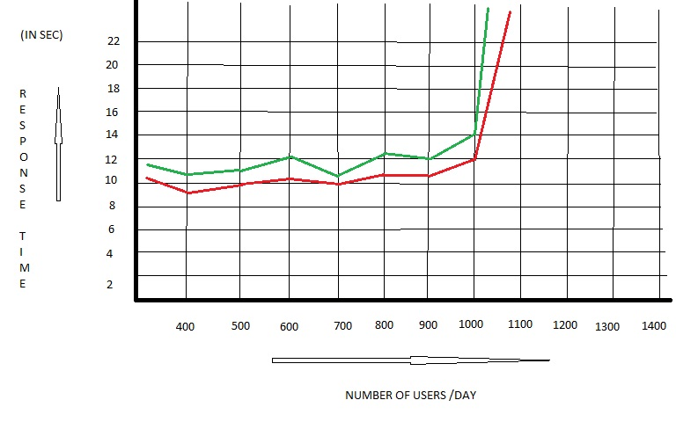
fig. 6.1(response time vs. no. of users graph)

if workload is highest between 10:00 AM and 8:00 PM then time duration user will active per day = 1000/10 = 100 users/hr

6.1.5 Capacity :
Capacity goals focus not on the system usage but on the system itself.
- Separate databases will be required to store the informations of users for the e-Services portal and for the back office system as well.
- Network bandwidth should support a maximum of 100 users/hr.
- Only 2 MB size of messages can be transmitted through SSDG middle-ware.

6.2 Safety Requirements
- Only Administrator can create the account for the officers and CSC operators.
- Role permissions should be hierarchical, based on the job of officers sitting on the Back office system.
- Intelligent routing of user application will be implemented.
- Log of every activity should be maintained.

6.3 Security Requirements
- As per the NeGP, SSDG middle-ware is used for verifying the identity of SAP (e-Service portal) and SP ( Back Office system) and also verifying whether a given SAP is authorized to send messages to a given SP.
- Authentication for SAP can be clear-password, encrypted password or based on digital certificates.
- Prevention from Fake Login Attempt. If anyone attempt unsuccessful login for more than three times, the predefined e-mail or SMS alerts should be automatically send to administrator and account will be blocked for the day .
- Connection between the e-service portal, SSDG middle-ware and the Back Office System will be based on SSL protocol.

6.4 Software Quality Attributes

6.4.1 Reliability
User may perform high reliable operation such as transfer of money through net banking/debit card/credit card etc., so application must be reliable.

6.4.2 Usability
- User will be able to use the website without any training.
- Software will be operable according to user expectations.
- Offers only required information as and when needed.
- Provide navigation control that are clear and obvious.

6.4.3 Availability
User will be able to access the website and perform any operation from any where at any time.

6.4.4 Maintainability

- Maintenance updates can be installed and immediately made available to the user through website.
- Application will be compatible with the old version.

Application will be visible to only permitted officers according to role based hierarchical system.

Password policy
1. Simple passwords is not allowed. It should contain atleast 10 characters including alphanumeric and special characters.
2. It can be clear-password, encrypted password or based on digital certificates.

Session policy
1. Session will not be longer than 30 minutes .
2. Session will be expired if user presses the close/cross button of the browser.
- Alert policy
1. Citizens will get alert through SMS and e-mail whenever he/she will login.
2. Live monitoring system will be there for the administrator to watch out every seconds of activity of the citizens and officers.

Appendix A: Glossary

Acronyms and abbreviations:
SRS - Software Requirement Specification
CSC - Common Services Centers
ID - Identification
TBD - To Be Done
SSDG - State Services Delivery Gateway
XML - Extensible Markup Language
MVC - Model-View-Controller
EJB - Enterprise JavaBeans
IIP - Interoperability Interface Protocol
IIS - Interoperability Interface Specification
IEEE - Institute of Electrical and Electronics Engineers
SAP - Service Access Provider
SP - Service Provider
SOAP - Simple Object Access Protocol
NeGP - National e-Governance Plan
SMS - Short Message Service

